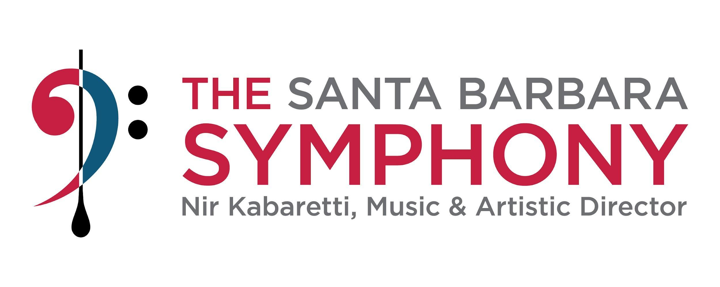

**DEVELOPMENT ASSOCIATE**

The Santa Barbara Symphony is experiencing unprecedented momentum and impact, and we are looking for a positive, engaging, results-oriented professional to actively support our Development Team in a wide range of fundraising and donor relations activities. The Development Associate is both an internally and externally focused role and a key member of the team creating a sense of connection with our donors and potential donors.

**POSITION SUMMARY**

Reporting to the Development Manager, the Development Associate is relied upon to ensure donors are accurately acknowledged, receive benefits, and feel connected through accurate record-keeping, correspondence, successful special events and the personal touches created by the Development Manager. The Associate is a key member of the team creating a sense of connection with our existing and potential donors. In an internally and externally focused role, this part-time position is relied upon for accuracy, consistency and proactive planning.

* Coordinate donor events including the logistics and operations throughout the season; manage inventory of supplies for such events, schedule and supervise volunteers.
* Process donations and ensure the accuracy of gift coding in the Tessitura database
* Coordinate and track donor benefit fulfillment
* Provide support for the front desk and incoming calls during the day
* Support and coordinate a variety of year-round appeal campaigns
* Other administrative and operational tasks required to fulfill objectives

**Attributes a candidate may find helpful:**

* Bachelor's degree preferred, but not required
* Minimum 2 years of Development experience, including individual donor & corporate sponsor stewardship.
* Ideal Candidates will have experience working in a non-profit development department.
* Excellent project management and communication skills; experience meeting deadlines
* Strong writing and communication skills, including handwriting, and exceptional attention to detail
* Excellent customer service and interpersonal skills
* Should be proficient at Google Office Suite, Microsoft Word, Excel and PowerPoint, working knowledge of Tessitura donor database (preferred).
* Must be able to lift a minimum of 25lbs.
* Must be available evenings/weekends as scheduled.

**Compensation and Benefits**

* This is a part-time, non-exempt position averaging 25-28 hours a week, with an hourly rate of $25.00 and may include evenings and weekends during the performance season

**ABOUT THE SANTA BARBARA SYMPHONY**

The [Santa Barbara Symphony](https://www.thesymphony.org/) The Santa Barbara Symphony is consistently lauded for its unique ability to present brilliant concerts, engage the community, and deliver dynamic music education programs. The organization prizes innovation and artistic excellence and is widely recognized as one of the region’s premier cultural institutions. Its award-winning music education programs serve more than 2,000 students each year and it is the only regional program tied to a college and a professional symphony orchestra.

**An Equal Opportunity Employer**

It is the policy of the Santa Barbara Symphony Association to provide all persons with equal employment opportunities without regard to race, color, religion, sex, sexual orientation, national origin, marital status, disability, age or Veteran status. Candidates of ALAANA (African, Latinx, Asian, Arab, and Native American) communities are encouraged to apply.

To Apply: Please submit your cover letter and resume to Juli Askew, Development Manager at [jobs@thesymphony.org](mailto:jobs@thesymphony.org)

 • No phone inquiries, please